IIIT HYDERABAD 24th Dec

--Kalyan Sir

5 thing that I'd like to do:

1.learn skills that will add value

2.develop marketing and communication skills

3.provide services that are required by others

4.work on projects

# **RECURSION**

1.Types of recursion.

2.Programmatic consideration of a recursion program

Base & sub function call

3.Causes of Stack Overflow in Recursion

Hypothesis:

No of calls

RAM

IDE

Based on Heap / stack

/ Read about Just in Time Compiler

/ process boundaries

/ virtual memory allocation

/ program to find the size of stack

<https://stackoverflow.com/questions/12687274/size-of-stack-and-heap-memory>

* Stack grows down and heap goes up

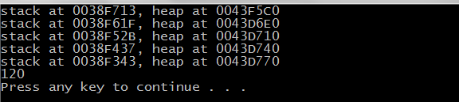

# To calculate the stack size(approx):

Find the diff btw adjacent memory locations of the n;

Multiply with the total no of calls;

Problems are given, find the

* Prototype of the function
* Sub function call
* Base condition

Good variable and function name

No global variable

IIIT-H 25th Dec

Read

* <https://discoverpraxis.com>
* http://www.swaraj.org/multiversity/gatto_7lesson.htm

Changes to improve approach towards learning:

* Maintain time for self assessment
* Indulge in activities that are of interest
* Work for value and not for degree or others
* Find matter that adds value

**STRING:**

* Mutable
* Stack pointer and base pointer
* Lifetime of stack variable is limited. Scope of function or call
* Process tool
* Virtual memory is backed by physical memory
* Lifetime of malloc is dependent and available till we free
* Machine uses 64 bit but the processes
* Char *a = “hey” . “hey” is neither stored in the stack nor in the heap; special
* Don’t use stack variables. Use heap variables and declare dynamically.
* Sizeof is called at compilation time.

## Problems

1. Remove spaces

In : size (n)

string( h e y)

Out: hey

2.Remove consecutive duplicates(case insensitive)

Ex : Aaccbaa

Out: Aacba

3. Remove substring from i to j.

Ex : apple 1 3

I - inclusive and j - exclusive

Out : ale

4.Replace i to j of one string with another string

5.Use run length encoding to compress a string if possible(case sensitive)

Eg: aaabbccccdD

a3b2c4dD

IIIT-H 26th Dec

Reading topics:

* <http://www.swaraj.org/shikshantar/bhave.html>
* https://discoverpraxis.com/dont-be-prepared-the-best-learn-to-the-task-not-the-test/

To solve the issue of VS hanging while creating a new project

* <https://social.msdn.microsoft.com/Forums/vstudio/en-US/c5aaa761-1a73-440e-bf72-ce70047169d6/help-visual-studio-hangs-creating-new-projects?forum=vssetup>
* C is unsafe. No protection of objects from each other.
* Char a[5];
* strcpy(a, “hello”);
* There is a layer of padding after each arry in the stack. This is
* calling convention. Default calling convention in C
* Calling convention for printf();
* Using dissasembly <https://stackoverflow.com/questions/1020498/how-to-view-the-assembly-behind-the-code-using-visual-c>
* 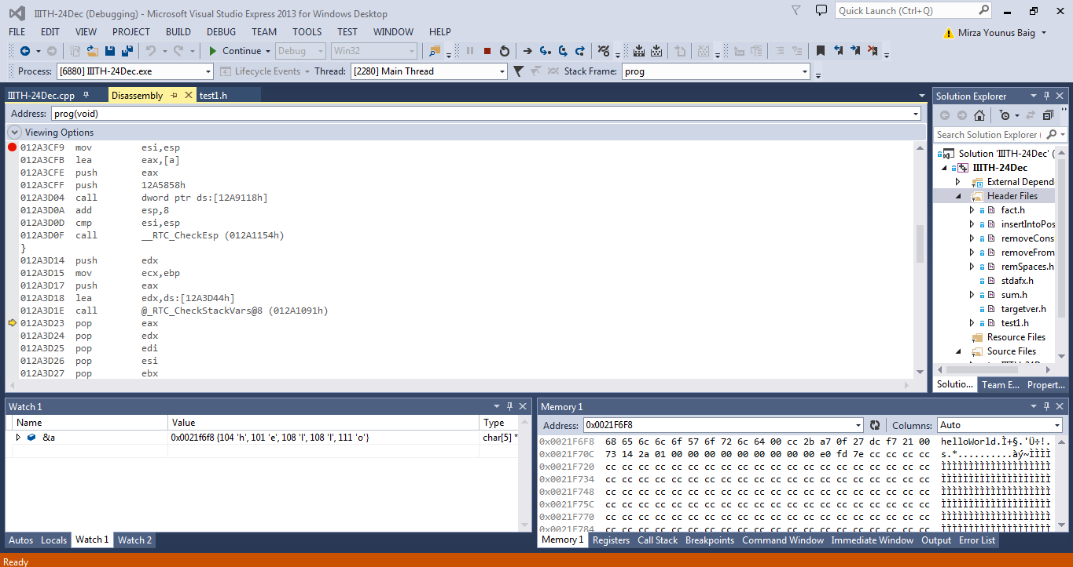

-use a int variable as string to point

- **Excercise** : corrupt portions of the stack and view in debug and release window

* Windows debugger *Learn to become good at windows programs and debug*
* [**https://docs.microsoft.com/en-us/windows-hardware/drivers/debugger/**](https://docs.microsoft.com/en-us/windows-hardware/drivers/debugger/)
* [**http://wingdb.com**](http://wingdb.com)
* 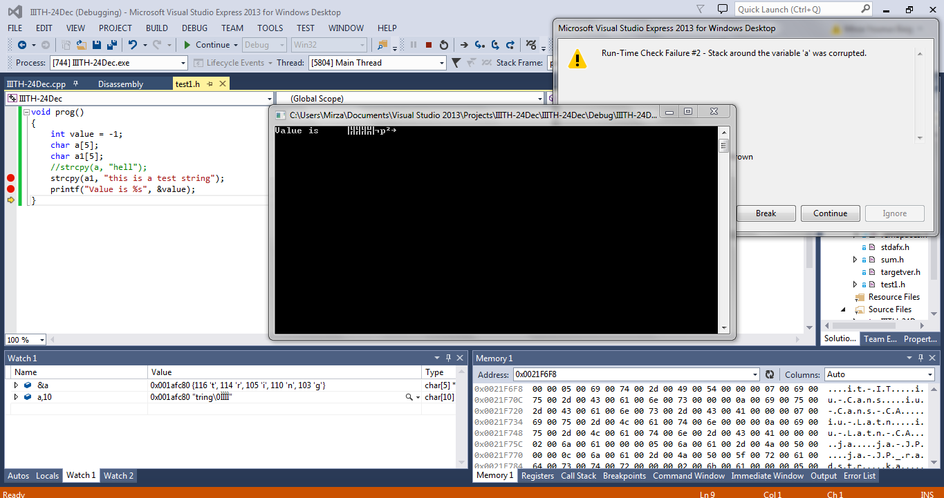
* Enable symbol loading
* Debug >> Options >>Debugging >> Symbols
* What calls the main function
* What facilities does windows provide to the processes

**Programmes :**

* Create a 2D array dynamically

Everything you allocate, free it. After freeing, assign that variable to NULL

Once the memory has been released, we can no longer access the variable components.

Free the linked pointer first and then delete the parent pointer;

# TREES:

Tree properties :

* Root
* Parent
* Children and others

Count of the children

Height / Depth

Weight

Balance = > height(left) - height(right)

**For each typeof tree answer in 0( ) notation:**

* **Max height / depth**
* **Max value of balance**
* **Max time for value lookup**
* **Max time taken to visit all node**
* **Describe the trees that correspond to these values**

1.Plain Binary Tree

* n-1
* N-1
* N
* N

Full Binary Tree

* n/2
* n/2 - 1
* N
* N

//<http://ckraju.net>

Complete Binary Tree

* Logn
* 1
* N
* N

Binary search tree

Balanced Search Tree

**Problems** : Based on the problems, identify the following

1. What traversal to use?
2. Function prototype
3. Visit function/code.
4. Max child in a given binary tree - postorder
5. Fill each node of the binary tree with the weight - postorder
6. Determine if the tree is BST - inorder